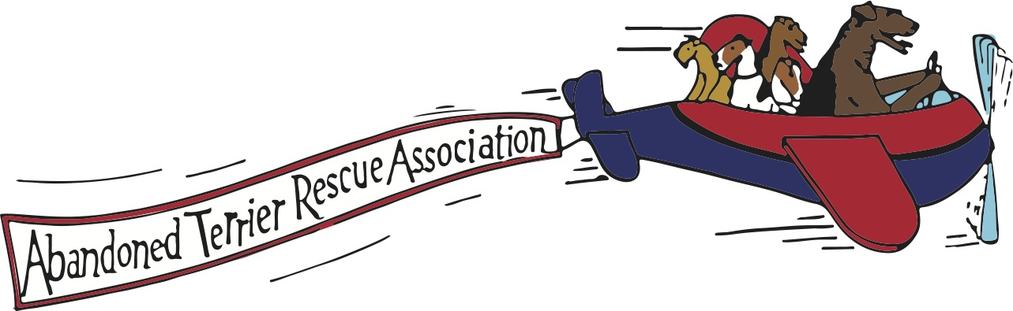

ADOPTION APPLICATION
APPLICANT INFORMATION Note: If additional space is needed, please use bottom of page.
Name:
Co-applicant:
Who will be primary caretaker?  Shared caretaking
Phones:
Home: Cell: Work:
E-mail(s):
Address:
City CA ZIP
Occupation (1) Full or Part time
Occupation (2) Full or Part Time
Do jobs require frequent travel? Subject to relocation?  Yes  No
What arrangement will be made for your dog during extended absences?
Caretaker to home Board kennel or vet Stay with Family Member  Dog will go along
○ Other (Explain)

Are you:  Single  Married  Live with parents
 Couple, not married  Military
Applicant(s) Age Range(s): 18-30 yrs 31-45 yrs  46-60yrs 61-80+ yrs
RESIDENTIAL INFORMATION
○ House  Condo  Townhome  Apartment  Trailer
○ Own  Rent
Years at current residence:
If rent, permission from landlord?  Yes  No Landlord name: Contact number:
Is your yard completely fenced?  Yes  No Fence height:
○ 3’  4’  5’  6’ Secure gates?
Fencing type:   chain link  wood  block wall  vinyl  invisible  other/explain
Doggie door to yard?  Yes  No
Pool/spa  Yes No If yes, fenced?  Yes  No
FAMILY INFORMATION
Household members and ages: Everyone want a Wire?  Yes  No (if no, please explain):
Frequent visitors? Please list:

Anyone allergic to dogs?  Yes  No
Describe your activity level: Low  Moderate  Active  Very Active
What activities do you plan for your dog?

PET INFORMATION-HISTORY-ROUTINE
HOW DO YOU ANTICIPATE A NEW DOG FITTING IN TO YOUR LIFESTYLE?

How long will your dog be left alone daily?
Where will your dog be when alone?
Where will your dog sleep at night?
Do you have knowledge/experience with: (Please check all that apply)
○ Grooming needs of a WFT House Training Obedience Training
○ Crate Training -if yes, when/how was crate used?
Will your dog primarily be:  Inside Outside Both
How would you handle behavioral issues such as accidents in the house, chewing, general misbehaving?

Any animals/livestock currently?  Yes  No
If yes, please indicate breed/sex/age/neuter/spay for dogs and list any other animals.

Any current dog with health issues?  Yes Explain:
Current dog ever lived with other dogs?  Yes  No
Current dog only dog?  Yes How long?
Any dogs that frequently visit? If so, please indicate breed/sex/spay/neuter.

Describe any previous dogs in your life, how long they lived with you, why they passed away. Also, please indicate where you obtained your previous dog(s)
BREED & GENDER | HOW LONG? | OBTAINED FROM | HISTORY
Have you ever sold, given away or surrendered a pet to a shelter or rescue?
Yes No If yes, please explain:
Has your dog ever run away and had to be reclaimed from a shelter? Yes No
ADOPTION INFORMATION
Why are you interested in a Wire Fox Terrier or other dog we may have?

Preferences:
Specific Dog(s)? If so, who?
Gender:  Male  Female Why?
Age:
Temperament:
Would you adopt a Wire Fox Terrier with minor health issues?
○ Yes  No  Depends on type of issue

Have you ever adopted from a Rescue?  Yes  No
From whom?  ATRA  Shelter  Other Explain:
When will you be ready to adopt?
Are you willing to have a Rescue volunteer conduct a scheduled home visit prior to adoption?  Yes  No
How did you hear about Fox Terrier Rescue?
Have you visited our website at www.atrarescue.com?  Yes  No
Have you visited our Facebook page?  Yes  No
Please provide a veterinary reference:
Name: Phone #
Address:
IMPORTANT INFORMATION
All rescues are spayed and neutered prior to adoption. An adoption contract is required and an adoption donation is requested prior to adoption. All donations go directly to the care of the dogs and help to defray veterinary costs.
By submitting this application for review, the applicant certifies that the information provided is accurate. If we determine that a material misrepresentation has been made, applicant understands that it will void this application from any consideration.
Applicant understands that providing proper grooming, food and veterinary care can be costly but applicant represents that (s)he is physically and financially capable of providing for an adopted dog.
○ YES, I UNDERSTAND THE ABOVE
SIGNATURE: DATE:
If you have questions, please call: 818 347-1029. Thank you for your interest in adopting!
