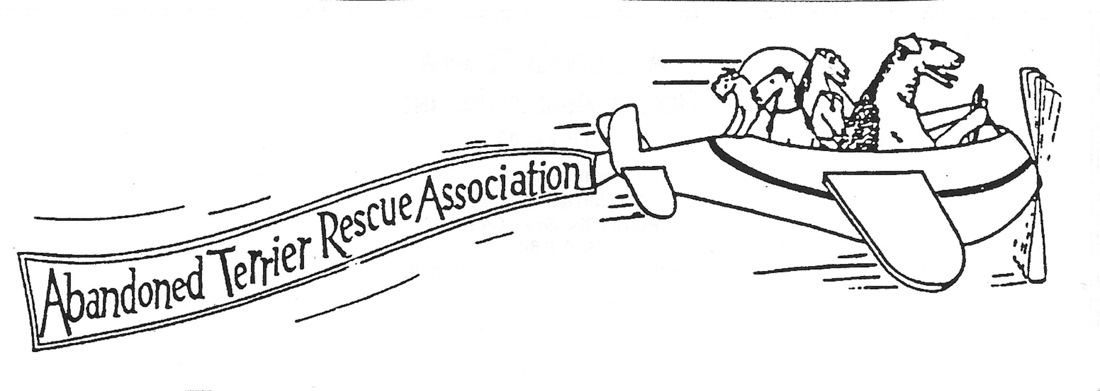

ONLINE DONATION FORM

This donation of $______ is in honor___in memory___ of:

Please send notification to the family:
Name:
Address:
City/State/Zip

Payment via PAYPAL_____ CC#___________________________ exp.______

Credit card holder: Name_____________________________________________
Address___________________________________________
Street/City/State/Zip Phone#

Online Donation 3/2015

